**NIKITA MOHAN MORE**

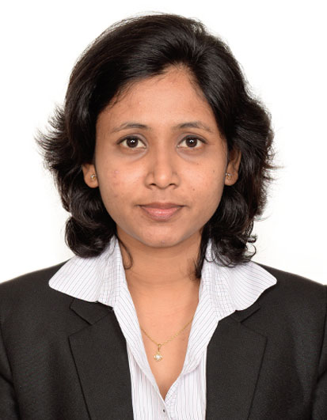

Union Deira, Dubai, UAE

Contact: +971‐55 135 9623;

Email: niiiks89@gmail.com



**OBJECTIVE**

Seeking an opportunity that offers a vibrant workplace where I can use my treasured sales experience and proven customer-relationship strengths to achieve professional, organizational & personal goals in the field of **Sales & Marketing.**



**PROFILE HIGHLIGHTS**

* Holder of Post Graduate Diploma in Management (**PGDM**) certificate (equivalent to MBA) with specialization in **MARKETING.**
* UAE Work Experience of **1 Year** as **Sales Executive**.
* **6 Months** Experience in telecommunication sector as **Sales Executive in India**.



**ORGANIZATIONAL EXPERIENCE**

**Company:** Saca Advertising LLC

**Location:** Dubai, UAE

**Duration:** January 2016- Present

**Designation:** Sales Executive

**Key Deliverables:**

* Working as a part of sales team to develop both new and existing market.
* Identifying potential buyers and their requirement.
* Doing door to door marketing to generate new clients.
* Managing and maintaining database of potential clients.
* Understanding customer requirements and accordingly giving quotations to them.
* Maintaining customer relationship.
* Managing customer centric operations and ensuring customer satisfaction by delivery timelines and service quality norms.
* Calling and mailing companies to generate new customers.
* Develop effective working relationships with customers through regular meetings.
* Identify and obtain further sales and business development opportunities.



**ACADEMIC CREDENTIALS**

* India Europe International Business School (IEIBS), Mumbai University 2012-2014

Post Graduate Diploma in Management **(PGDM)**

Electives: **Marketing**

* MCC College, Mumbai University 2009-2012

Bachelor of Management Studies **(BMS)**

Electives: **Finance**



**BEYOND CURRICULAM**

* **Active Member** of an NGO ( Umang Foundation, Mumbai)
* **Core member of the Organizing Team** for Beauty Forum 2013 (IMAGES Group).
* **Core member of the organizing Team** for intra college event and cultural sports event of IEIBS AKADEMIA



**SKILLS**

* Good Communication Skills.
* Positive, pro-active and self-motivated.
* Proven ability to work under pressure to achieve monthly targets.
* Able to work individually or in a team.
* Able to build relationships with customers.
* Confident and able to take initiative.



**PERSONAL DOSSIER**

* **Date of Birth:** 10th of December, 1989
* **Passport No:** H5793556
* **References:** Available on request